**ABOUT**

**TED**

TED is building a clearinghouse of free knowledge from the world's most inspired thinkers — and a community of curious souls to engage with ideas and each other, both online and at TED and TEDx events around the world, all year long.

What started as a small idea grew out to change the world for the good. TED at its core believes that the stem of every great idea is an inspiration and TED tries to spark and ignite this inspiration by sharing heart touching, inspiring and motivational stories. Over the decades of inspiring budding minds, TED has achieved recognition throughout the world.

**TEDx**

The community voice of TED takes the form of TEDx where x represents “independently organised event” under the license of TED.

TEDx events are organized by curious individuals who seek to discover ideas and spark conversations in their own community. It is a platform to reach more people at the community level.

Each community has its heroes, people that are constantly yearning to create, explore, imagine new ideas. TEDx aims to bring these people together and give them a stage, so they can share their story, for other people to create their own and give something to the world.

**TEDxShivajiCollege**

Shivaji college takes another step to improving itself and growing to become more vibrant in creativity and excellence with initiatives by students under the guidance of professors who are there to support them on every step. As a learning opportunity, this event aims to create new thoughts and paths for the future of this nation. We hope to provoke the zeal and inspiration that will cause a change in our lives to excel and improve.

Like last year, TEDxShivajiCollege aims to bring the best in the community, to their people and give them the spotlight they have earned to share their story with us. We strongly believe that the right change in the thinking can only be brought on by the growth of everyone together, learning from each other.

**Shivaji College**

Shivaji College is a premier institution in West Delhi, accredited with grade 'A' by NAAC. It was ranked as one of the top 10 science colleges of the country in a survey conducted by India Today in 2017.

Shivaji College functions under the trusteeship of the Government of Delhi. In spite of being located in the thriving part of the city, Shivaji College campus is extremely verdurous. It has a maze of tall trees, lush green lawns and pruned hedges.

Shivaji College believes in and promotes the ideals of gender equality and community service.

Shivaji College has come a long way from its humble beginnings and moderate facilities to a campus equipped with impressive amenities.

* 2EVENTS

* 18SPEAKERS

* 180+AUDIENCE

* 5000+VIEWS

**SPEAKERS**



**Naghma sahar**

Senior Editor and Anchor - NDTV India

Ms. Naghma is working as a Senior Editor and Anchor at NDTV India and also as a Senior Fellow at ORF in Digital and New Media . Her show Salaam Zindagi was widely appreciated for sensitively handling social issues and bringing them to the front.

Through sheer hard work and perseverance, she has carved a niche and raised the bar in the field of journalism.



**VARTIKA NANDA**

Founder- Tinka Tinka Project

Ms. Vartika Nanda is a media educator who raises awareness about the issues in the coverage of rape cases by Indian print media. She has also striven as a prison reformer to bring a positive change in the lives of jail inmates through Tinka Tinka project. She has been awarded the Stree Shakti Puraskar. Her contribution in creating awareness on womens' issues is truly commendable and unparalleled.



**MAYANK VATSA**

Professor - IIT Delhi

Mr. Mayank Vatsa has inspired everyone with his research in the field of biometrics, image processing, machine learning and information fusion. His research on Neural Cognition and Networks serves as one of the momentous milestones in the fields of technology. His experience as one of the most well versed professors in  IIIT-Delhi is no less than astounding. The inspirational work he has done in the field of technological advancement remains unparalleled.



**ADITYA KV**

Founder - Umoya Sports

Mr. Aditya KV is the founder and CEO of Umoya sports . It has not only helped to provide an equal platform for differently abled people but has also enriched and empowered lives of many. His efforts aim at providing holistic development and bringing 'Joy of Sports' in the lives of people with disabilities, which truly celebrates the belief that sports benefit all equally.



**PARITOSH TRIPATHI**

Actor/Comedian

Mr. Paritosh Tripathi, with his enthralling performances as an actor, anchor and a comedian, has certainly carved a niche in the entertainment industry. Playing the ever funny and cheerful TRP Mama, not only garnered him appreciation but also left a notable mark on all. His passion and hard work can be seen in all his works,  from acting in many soap operas to hosting famous reality show like Indian Idol.



**DIVYANSH GUPTA**

Beatboxer

Divyansh Gupta is a beatboxer by profession. His contribution in the field of entertainment has been tremendous. He has brought recognition to beatboxing has motivated many to explore their potential in the same. He has been a season 3 Finalist and a season 5 winner at MTV's Colour of Youth. He has performed at various prestigious events and even judged a Beatbox Battle in Rendezvous, IIT(D).



**MEETA GUTGUTIA**

Co-founder - Ferns and Petals

Meeta Gutgutia is the co-founder of 'Ferns and Petals' and 'Sipping thoughts'.

Her aesthetic and design sensibility have made Ferns N Petals the design leader, winning many awards and accolades. She also has to her credit, the launch and successful running of Sipping Thoughts, which is a women-centric media platform that enables women to share real stories and their experiences. She believes in constantly doing well for the betterment of the society and actively comes up with projects where she can contribute to her maximum.

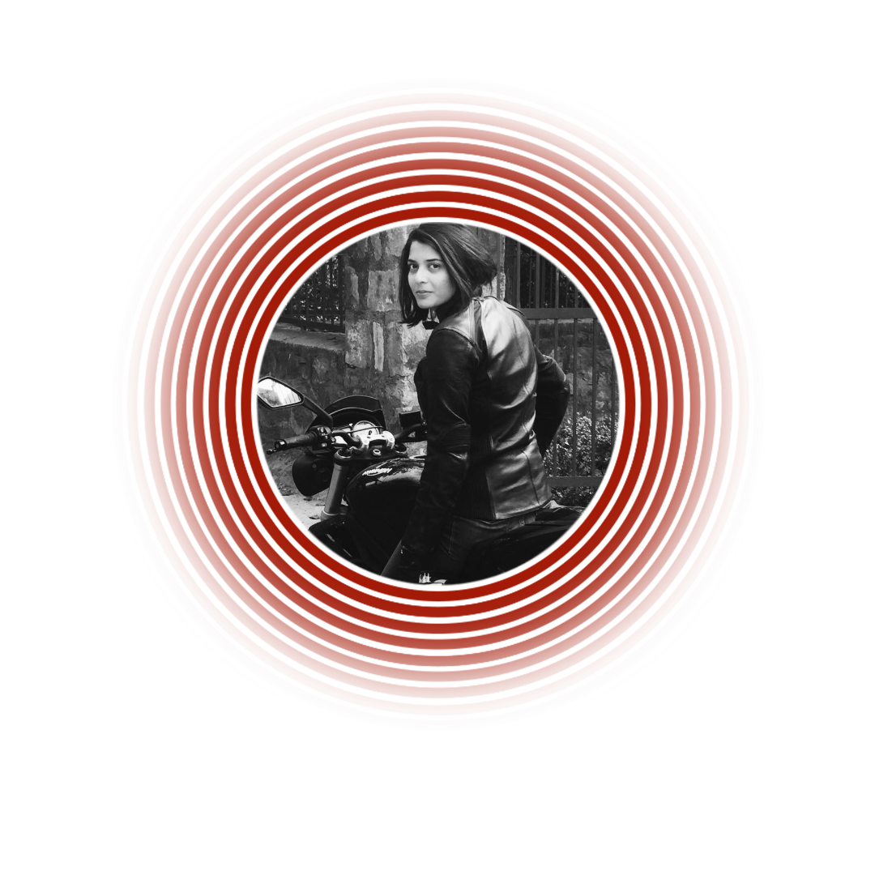

**SONIA JAIN**

Motorcyclist

One of the best and top competitive motorcyclists and long-distance riders in the country, Sonia Jain has a bold personality and influential persona. Her strong-willed actions and resolute have been the symphony of true women empowerment. Of her most recent accomplishments In August 2018, Jain embarked on a 5000 km Tri-National ride from Delhi to Bangkok, Thailand via Myanmar.



**Mansi Sehgal**

Influencer

Mansi Sehgal was honoured with the title of FBB Colors Femina Miss India Delhi, 2019. She is student of Netaji Subhash University of Technology. Her journey started from being the Campus Princess Finalist 2019 . She has her own startup company funded by the government . She has made huge efforts to spread awareness on organ donation . She motivates many to follow their heart and yet continuously work to make a difference in the society.

**PARTNERS**

TEDxShivajiCollege wouldn't have been possible without the support of our partners. Their association with our event, is a testimony that their brand/organisation believes in and promotes learning, innovation and insightful conversations.

**Title Partner**



**Gaming Partner**  


**Gifting Partner**  


**Eye Care Partner**  


**Media Partner**  
   

**Stationary Partner**



**TEAM**

These people turn TEDxShivajiCollege's idea into reality. TED enthusiasts, these people firmly believe in the power of ideas to bring about positive change and work towards the same through this event.

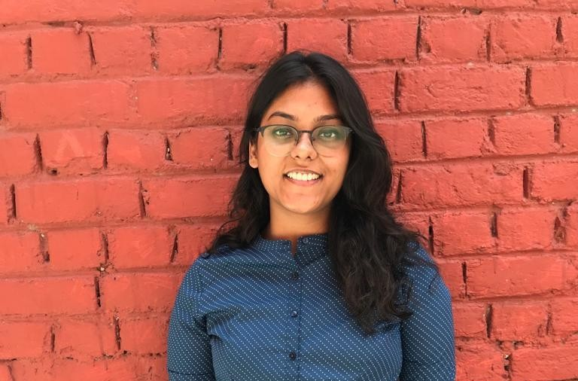

**Kunjana Gupta**

Organizer

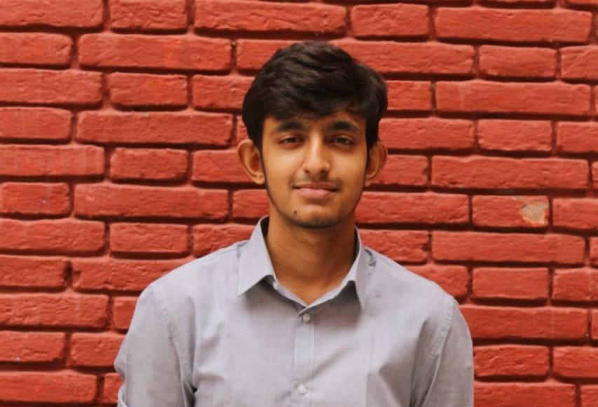

**Anmol Sharma**

Co - Organizer

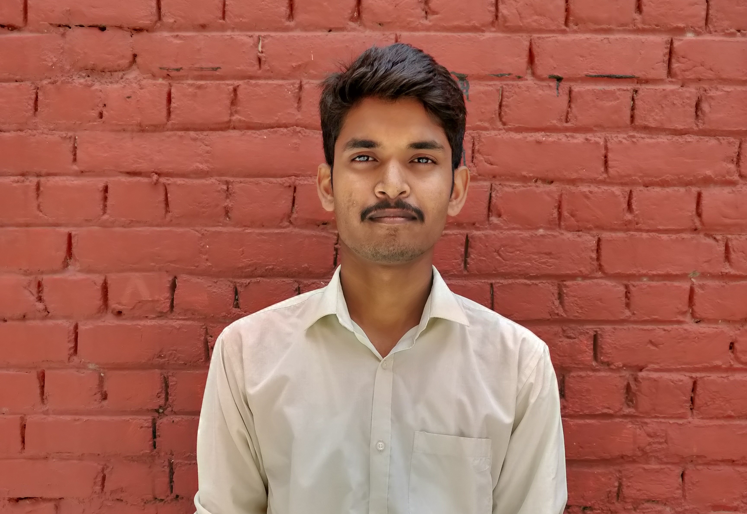

**Shourya Gautam**

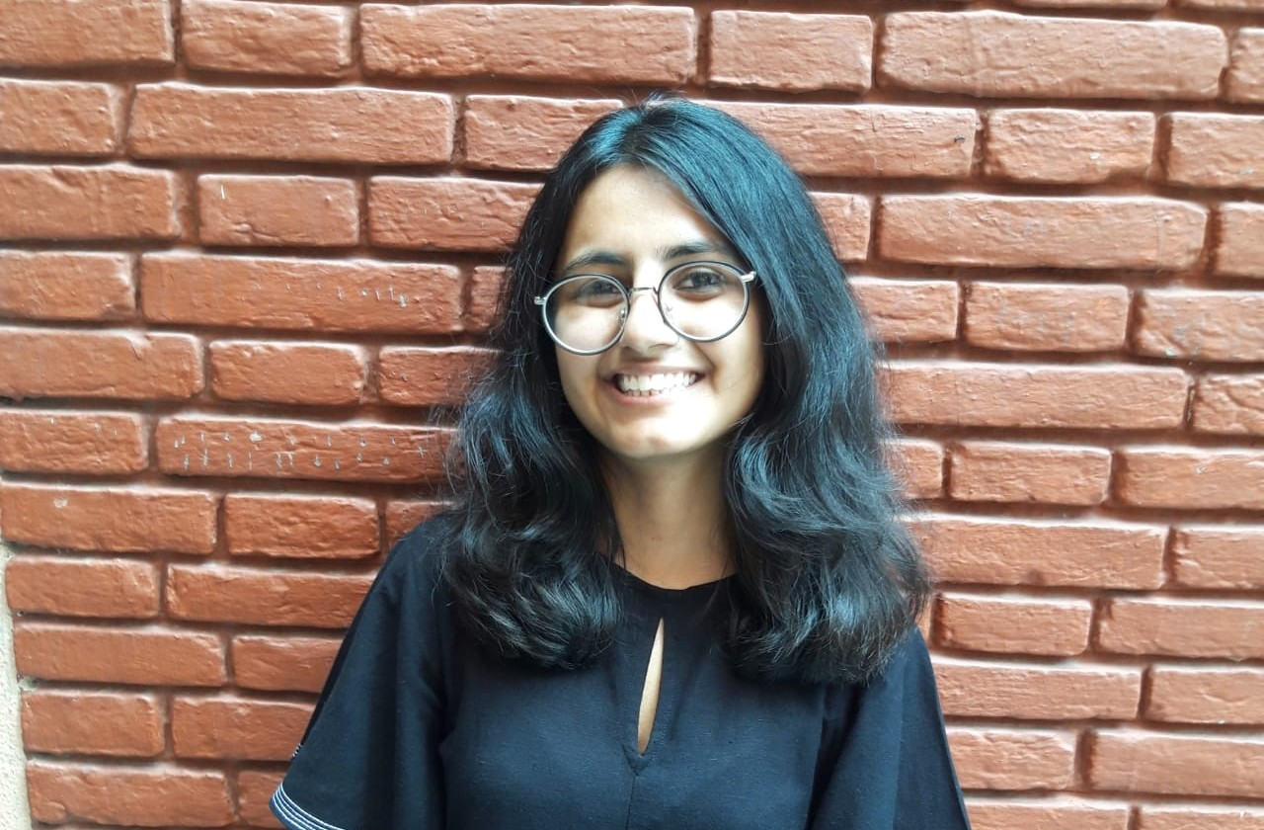

**Sanya Chhabra**

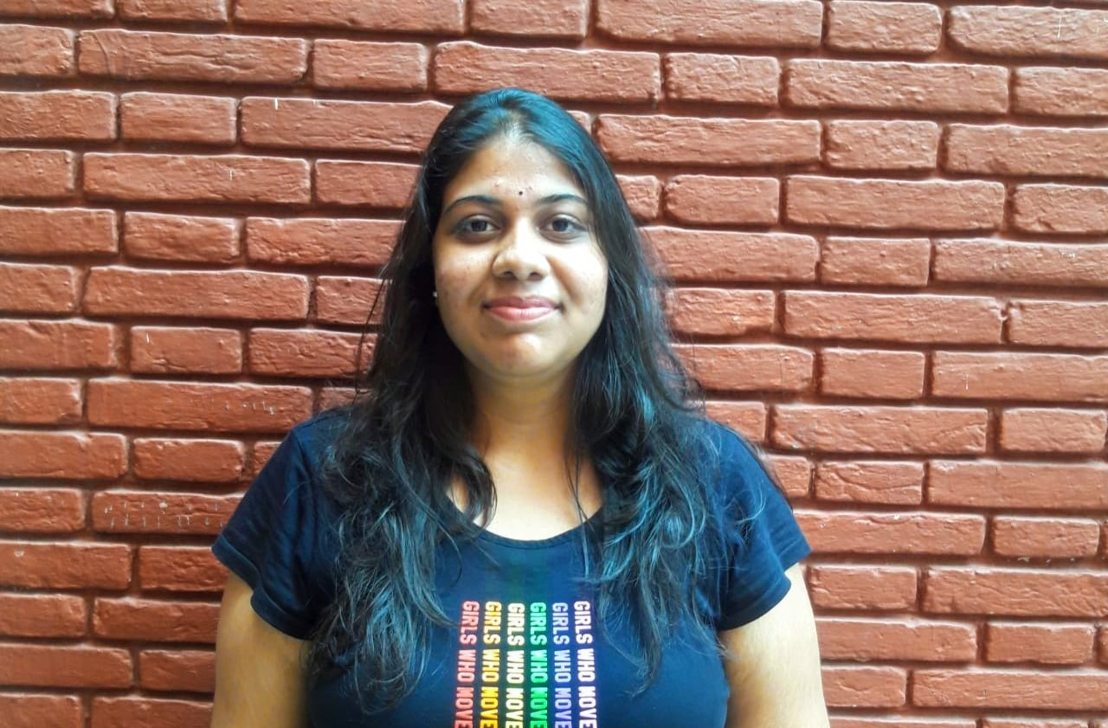

**Shivani Kaul**

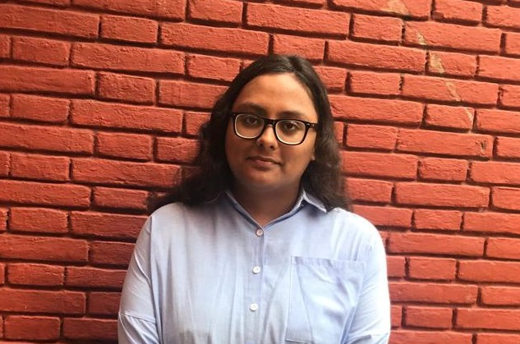

**Kanak Sawlani**

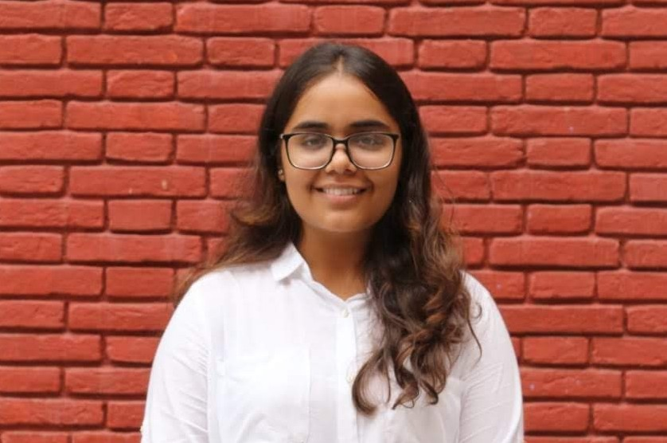

**Sonal Arora**

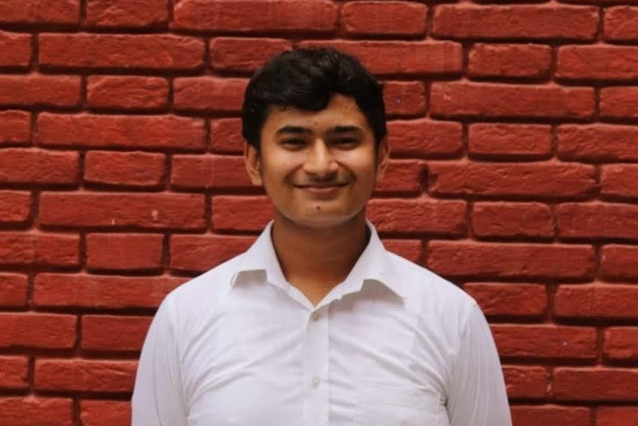

**Ankit Joshi**

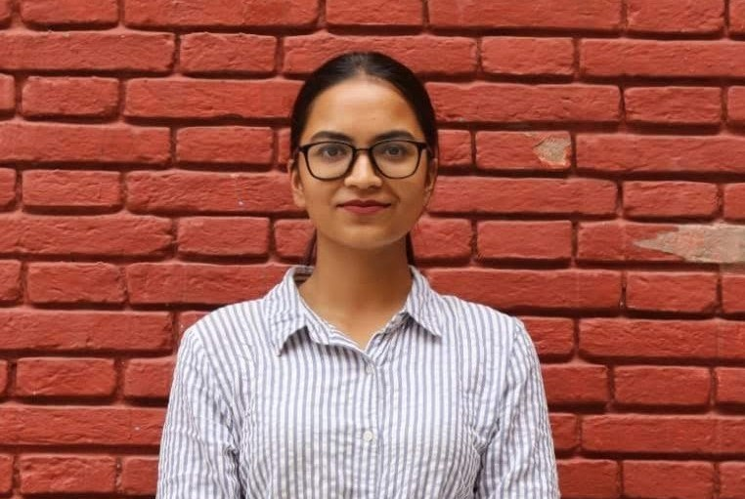

**Arushi Sharma**

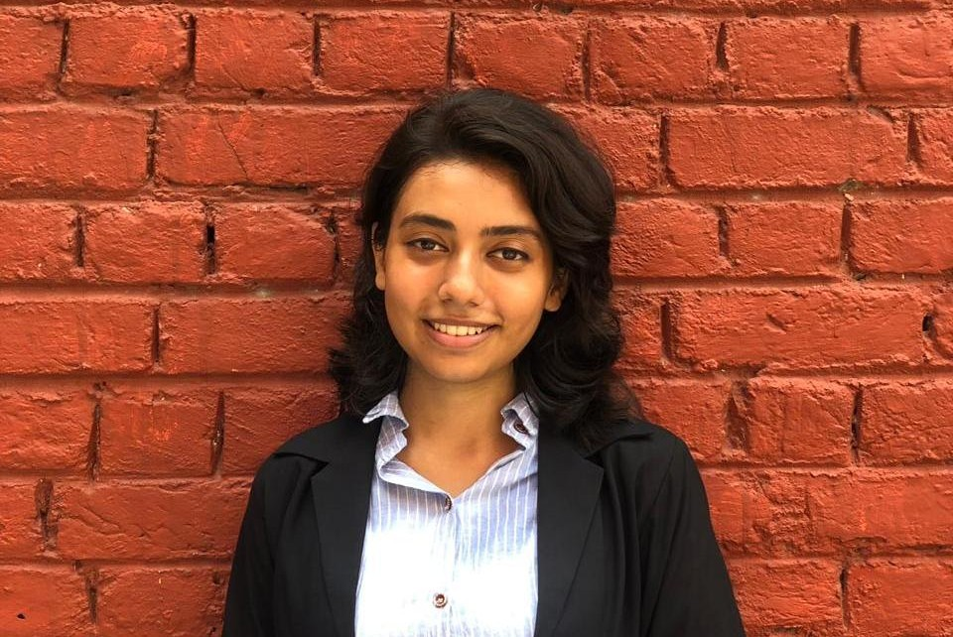

**Aarti Garkoti**

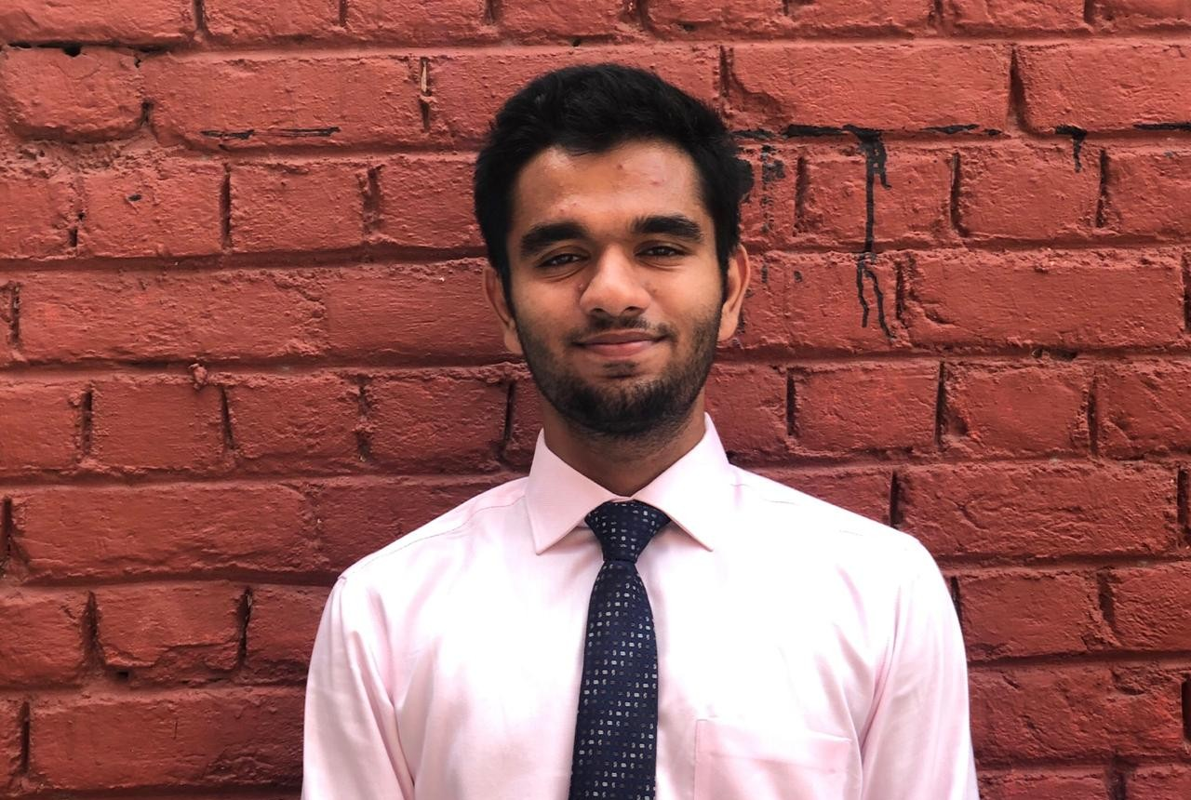

**Aarsh Dubey**

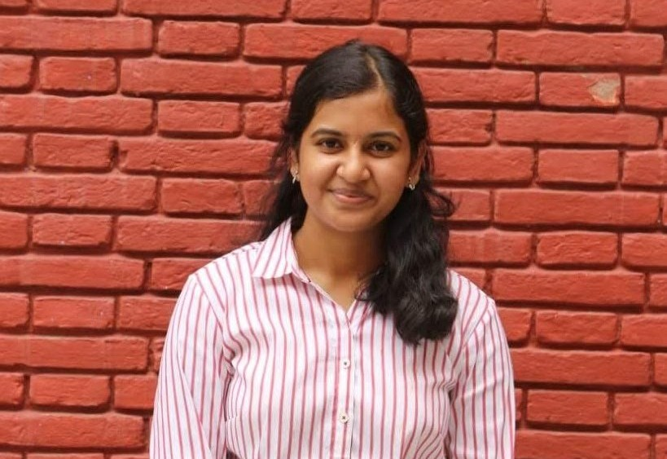

**Anubhuti Chitra**

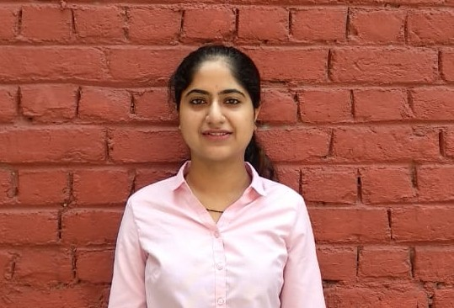

**Naina Rajan**

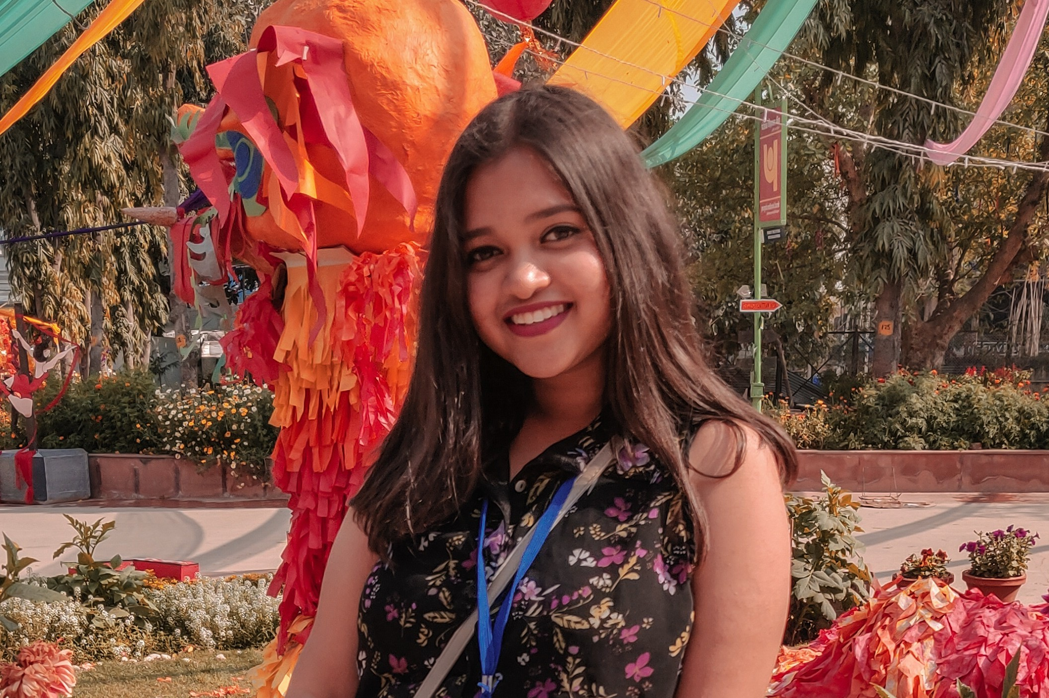

**Prokrita Chanda**

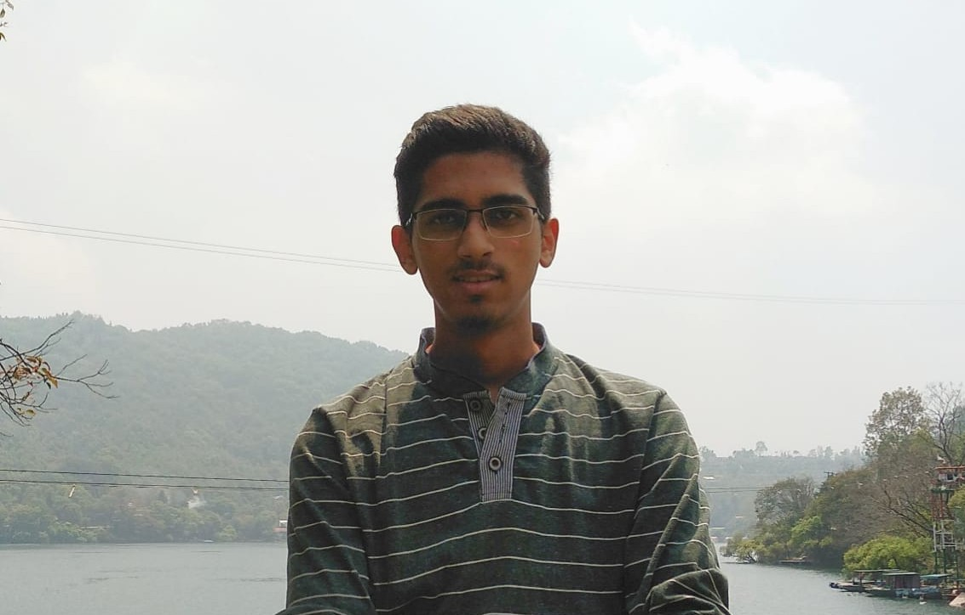

**Shivam Vatsa**

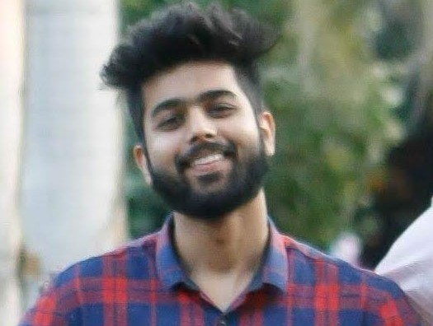

**Sanyam Jain**

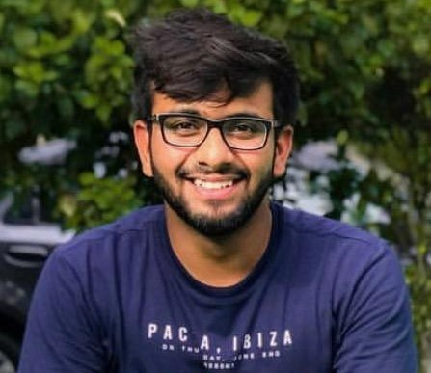

**Chirayu Arya**

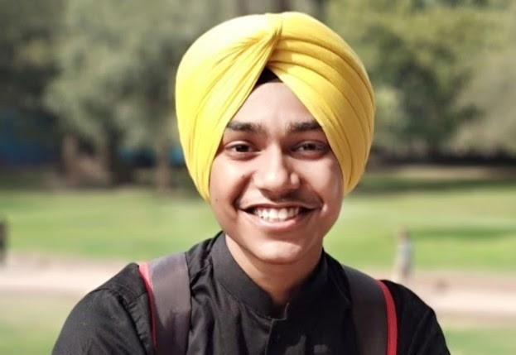

**2018**

Haven't you always wondered what it would be like to take a moment for yourself in this busy life? The theme F5 discusses the importance of taking a step back from your busy life and hitting refresh. When your day gets busy, it is necessary sometimes to stop for a minute, think reflect and then inspire. This will give a fresher and more diversified perspective. Moreover, it will also help in creating new ideas worth spreading.

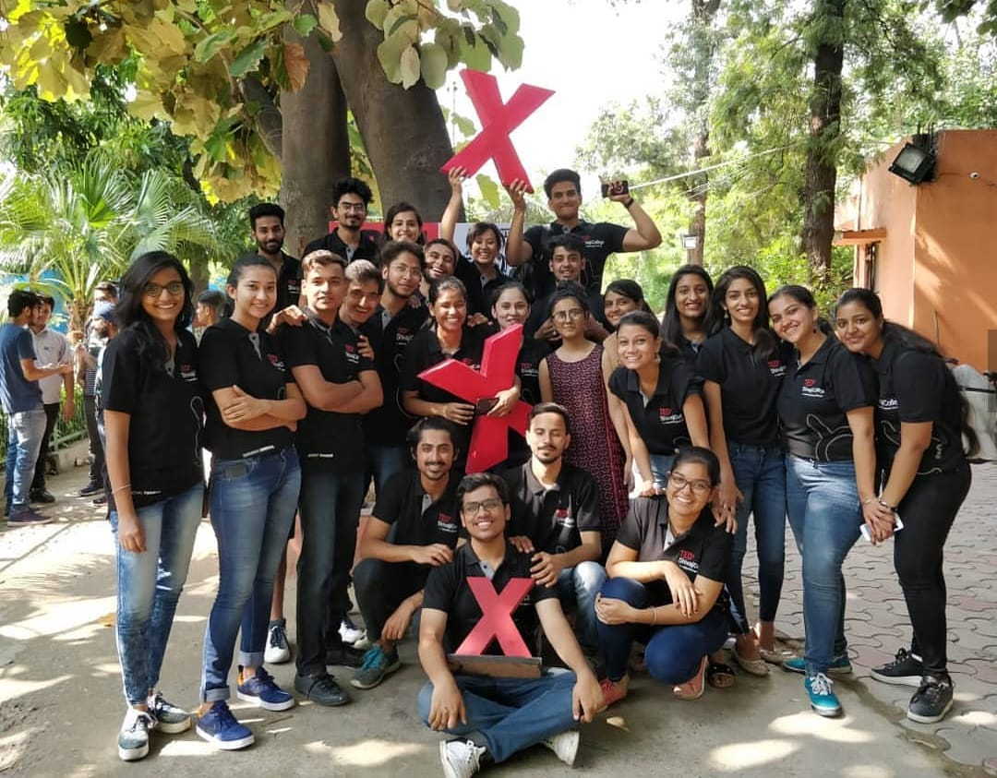

**SPEAKERS**



**Amrut Bhat**

Drum Circle Facilitator

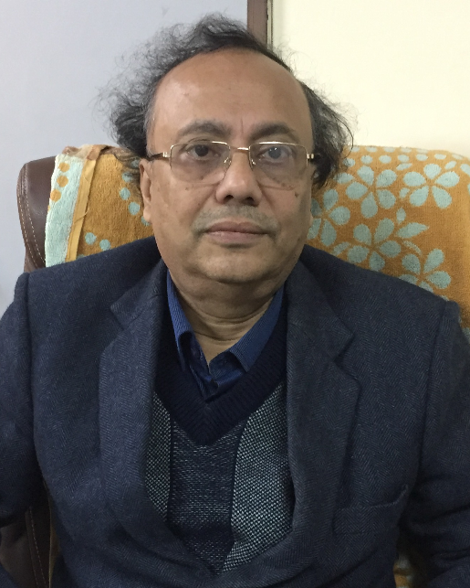

**Niladri Chatterjee**

Professor IIT Delhi



**Ginnie Mahajan**

Radio Jockey

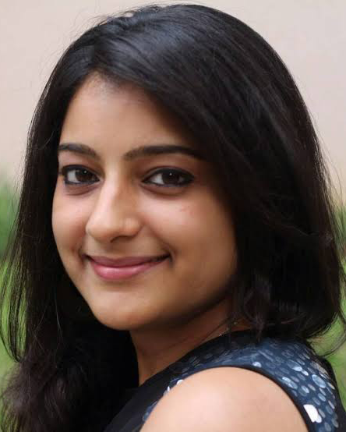

**Shruti sharma**

Author



**Rudrani Chettri**

Model / activist

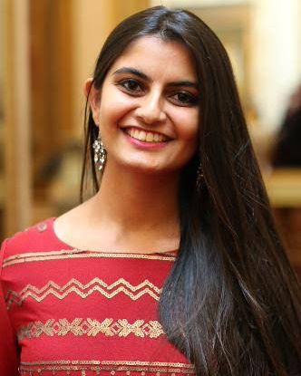

**Suhani Jalota**

Founder / ceo , Myna Mahila Foundation

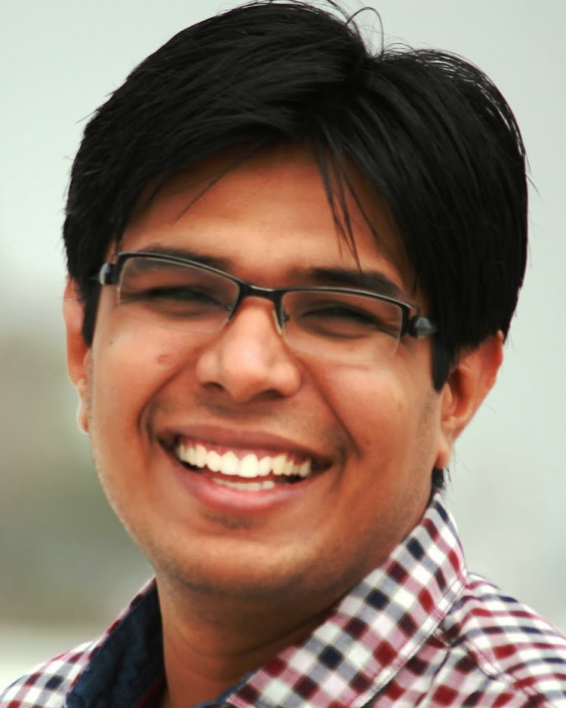

**Divya Prakash Dubey**

Author / storyteller

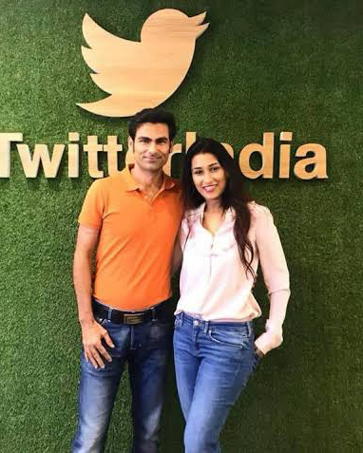

**Mohammad Kaif and Pooja Kaif**

Former cricketer ; Corporate Author

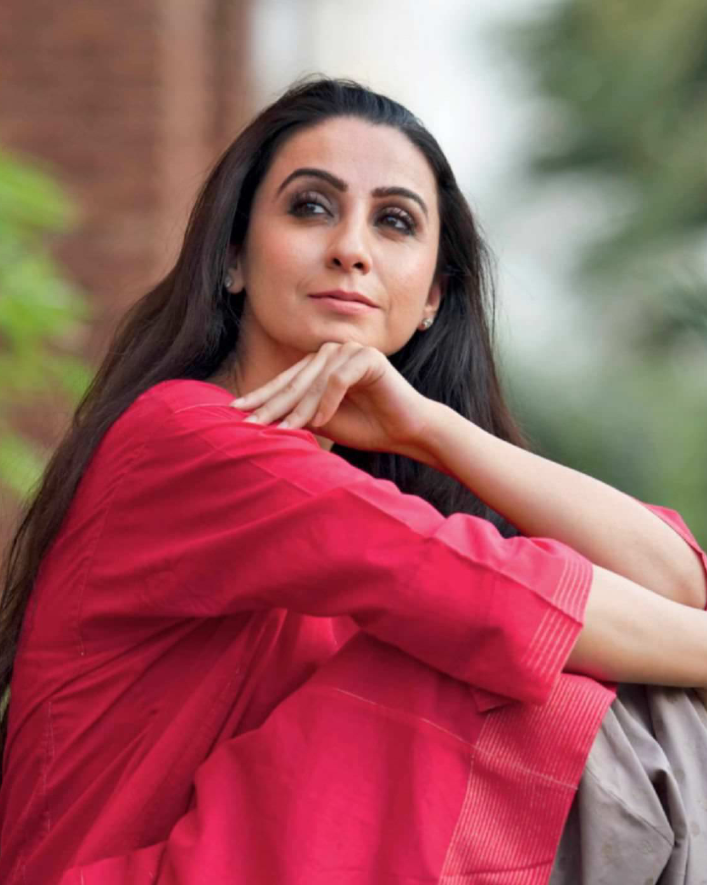

**Anamika Singh**

Performer / Dancer , Founder - ADAA